
Drug addiction is a disease, according to the National Institute on Drug Abuse (NIDA), the federal focal point for research on drug abuse and addiction, which has been part of the National Institutes of Health since 1992. NIDA’s mission is to lead the nation in bringing the power of science to bear on drug abuse and addiction. NIDA estimates that substance abuse for illicit drugs, tobacco, and alcohol — including health- and crime-related costs and losses in productivity — exceed half a trillion dollars annually.
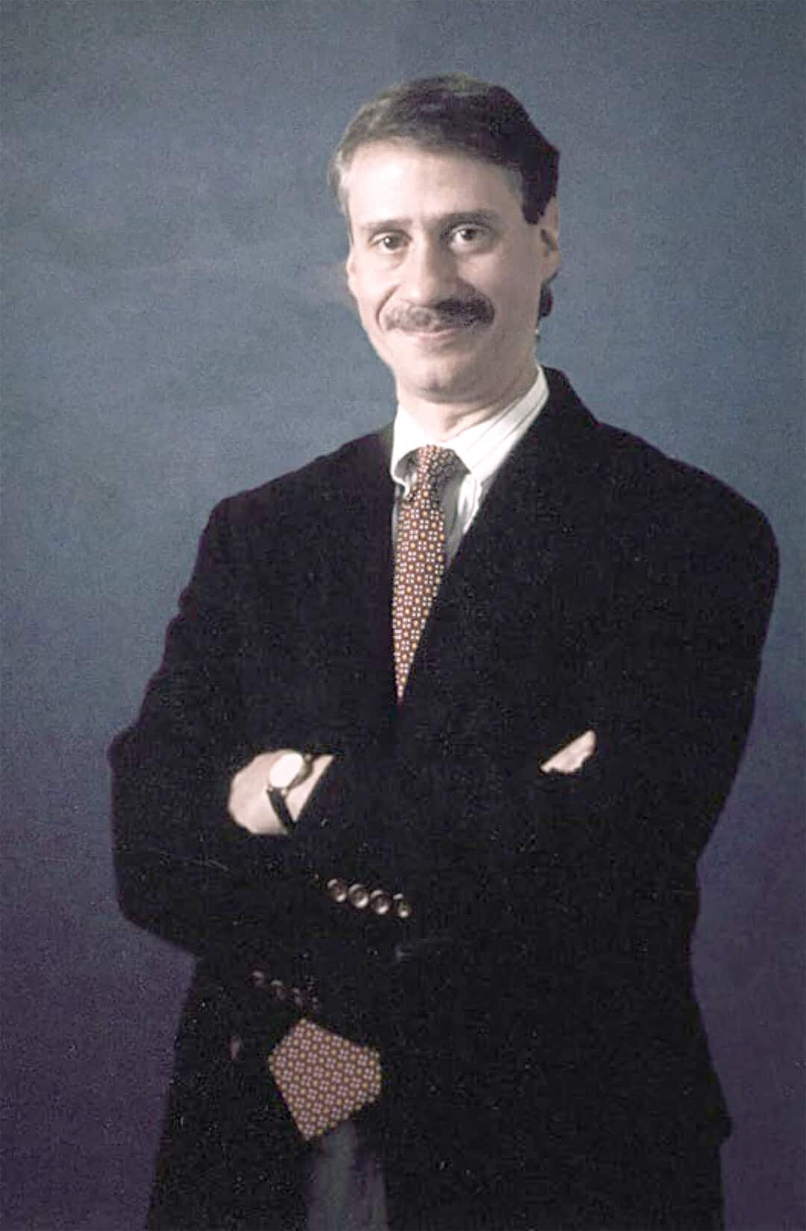
Dr. Joseph Frascella, an NIDA senior science adviser and former director of NIDA’s Clinical Neuroscience and Behavioral Research Division, is well versed with a broad drug abuse and addiction program of translational research with research training in behavioral treatment, clinical neuroscience, and human development. Frascella discusses how drug addiction changes the brain, why children are particularly vulnerable, and how neuroscience and brain imaging can change what the future holds for treatment.
Brain World: Prior to your work with drug addiction, you worked with NIDA’s pain research program. Why did you get involved in this field?
Joseph Frascella: I just found the brain is the most fascinating, complex structure in all of the universe. There’s nothing more fascinating than studying the brain and its mechanisms — and the different processes that underlie behavior.
BW: Is drug addiction a disease?
JF: We like to think of it as a disease. Addiction is the result of a changed brain, and like many diseases, there is a change in the structure of the function and the end organ. The organ for addiction is the brain, and this change in brain structure and function changes behavior.
Drug abuse or drug use goes from a voluntary set of actions and behaviors — at some point something changes, and we’re not quite sure about that something. We hear “a switch goes off,” or you “spiral down” — at some point, voluntary behavior becomes involuntary. There is a change in the brain such that we are no longer able to control our behavior. That is one of the defining elements of addiction — where we no longer are in control of our behavior.
BW: Why is it important to classify drug addiction as a disease?
JF: It has to be treated as a disease, as something that has broken that needs to be fixed. We are trying to understand how the brain changes, and how the changes relate to changes in our behavior. So given that you need treatment to “cure” the disease, the disease model makes a lot of sense. It’s better than people thinking addiction as just a moral issue: bad people doing bad things. If you understand that addiction is a switch from voluntary to involuntary — once the choice is made, once you get into a compulsive drug-seeking state, when you’re no longer in control — it’s no longer a moral issue. It’s a changed-brain issue.
BW: Does classifying addiction as a disease absolve people from responsibility of what was initially their choice?
JF: People do make a choice to abuse drugs, but in a sense, it’s a bit like Russian roulette. We don’t know which people can dabble in substances — be it legal or illegal — and walk away, versus those who get addicted. We don’t know enough about the brain and these individual differences that could put someone at greater risk to become addicted.
The recognition that this is a disease shows that the “just say no” attitude doesn’t work. I can’t stop any time I want — it’s a changed brain, and it’s very difficult. Most people need to go into treatment. This is a disease — a relapsing disease — and it’s difficult to stop. People with diabetes need insulin all their lives. To put people in drug rehab for two weeks or 30 days and expect them to live a drug-free life — it’s may be too much to ask for.
BW: How do drugs affect the brain?
JF: Drugs get into the brain and they affect certain receptors, transmitter systems. We’ve been looking a lot at the dopamine system. We know that all drugs of abuse function to release dopamine. Dopamine is also released when we have a good meal, hear a beautiful piece of music or see a piece of art that’s appealing to us — these are natural rewards. But addictive drugs are so potent, releasing so much dopamine, sending signals to us that become very hard to resist — just as many people talk about certain foods that they find hard to resist because they taste so good.
BW: Why are we built this way?
JF: Our reward system has evolved over many thousands of years as a survival system. It’s a system that the brain has evolved — we repeat behaviors that are seemingly good for us, like feeding. If we didn’t have a mechanism that told us we are hungry, we might forget to eat. Or for propagating the species. There are lots of things we do that are good for our survival, and we have this reward pathway that has evolved. So if we take in a meal that’s high in calories, the brain says, “That’s good! I should do it again!” Certain behaviors are very reinforcing.
BW: Do all drugs affect the same parts of the brain?
JF: No, but they all hit the central reward system and release dopamine.
BW: What is the biological etiology of drug addiction?
JF: We are really trying to study what are the individual differences — for some people it’s genetic, for others it’s environmental, or a mix of both. Certainly it’s “epigenetic,” meaning, changes in the gene from the environment. Why is it if I smoke a few cigarettes I might go on to have a long lifetime of nicotine addiction, whereas others can smoke lots of cigarettes but not become addicted?
It’s a very complex biobehavioral disease — it’s not just neurological, because there’s a lot of play between the brain and behavior. Our behavior can change our brain. We often think if we take a drug it will change our brain and our behavior changes, but it could be the opposite — and that may be the way out for treatment. We can engage in risky behavior if our phenotype is very impulsive and thrill-seeking, living fully, and on the edge. That behavior could lead us to experiment with drugs. And behavior can change the brain, too. I think that will be some of our success in treatment: to change behavior then change the brain, not always looking to change the brain first.
BW: What kind of behavioral treatments do you have?
JF: We have a behavioral therapy where people are given behavioral strategies to deal with drugs and addiction, such as a set of studies on contingency management, where they are given reinforcers to come in with clean urine — food stamps, money, CDs. Even small reinforcers can change behavior and have people effectively abstain from taking drugs. A combination of medications and these treatments will be extremely effective treating the complexities of this disease we call addiction.
BW: Is there a gene for drug addiction? Are there people or groups that are more resistant to drugs, similarly to the way that Asians and Jews have been found to be genetically intolerant of alcohol?
JF: Our research is now trying to figure out what genes are involved. There are going to be certain subtypes, a certain genetic makeup for substance intake. Certain people will have certain genetics, so our treatments could be modified to better target different people. People respond differently to different medications, for example, not everyone takes the same blood-pressure medication.

